ORDER YOUR MEAL PREP NOW!
Please select your choice by choosing the numbers that best fit your needs.
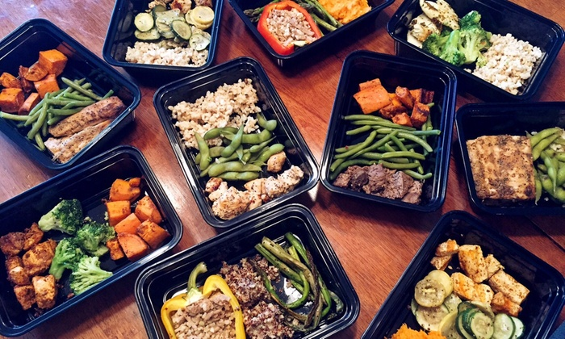
- Oven baked BBQ chicken, baked sweet potato and green beans.
- Baked cilantro lemon, boneless skinless chicken thighs
- Oven roasted bell pepper, stuffed with spinach, chipotle pepper ground turkey, sweet corn, cilantro and Italian three cheese blends
- Black pepper lemon glazed salmon with garlic butter green beans and jasmine rice
- Jerk chicken thighs with lime, herb Jasmin rice with freshly chopped scallions
- Black pepper lemon glazed salmon with garlic butter green beans and jasmine rice
- Shrimp and broccoli steamed rice
- Chicken fajitas with black beans and spicy rice
- Vegetarian fried rice
- Rosemary chicken thighs with sautéed green beans and zucchini
- Organic veggie stir-fry dressed in citrus ponzu sauce, with spiced jasmine rice.
- Zucchini turkey spaghetti
- Turkey meatloaf stuffed with sautéed spicy spinach, roasted lemon pepper corn and baked sweet potatoes

